Borrado de Clúster

Este programa estándar que se le incorpora la opción de selección automática, de otro programa estandar.

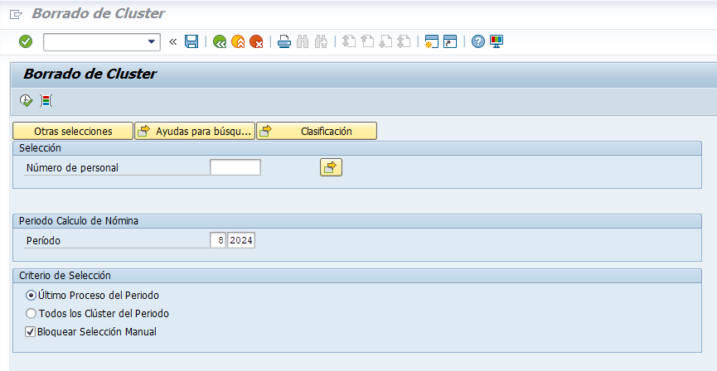

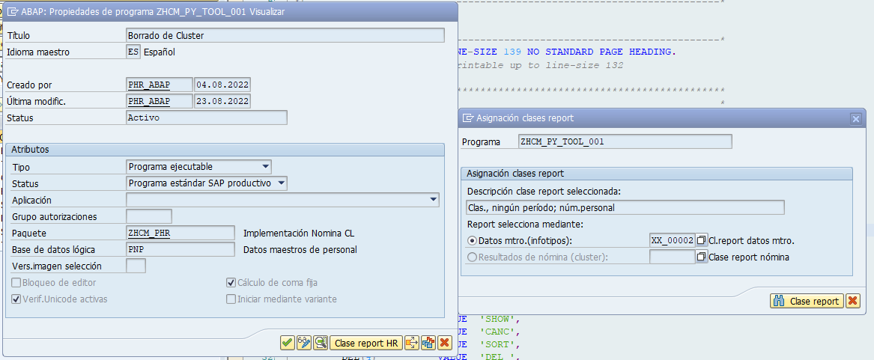

**Símbolos de Texto**

003 N° personal

004 Result.cálculo nóm.

005 No existe autorización para actualizar cluster

007 Registro de resultados de nómina marcados borrado

008 y cluster CU actualizado

009 Ning.entrada en tabla T550L p.agr.países =

010 No existe número de personal

020 Borrado de resultados de nómina

021 puede causar inconsistencias

022 (Resultados marcados en rojo ya han sido contabil.)

023 ¿Desea borrar?

026 ¿Borrar?

029 Error en módulo de funciones CU_READ_RGDIR para núm.personal

041 Algunos resultados cálculo nómina marcados

042 no existen.

043 La siguiente pantalla visualiza la lista actual.

071 contiene resultados marcados para borrado

072 no posee resultados cálculo nómina

081 Se encuentra en un mandante no específico

082 Report sólo previsto para fines de test

083 ya que puede originar inconsistencias en set de datos

084 ¿Proseguir a pesar de ello?

085 Advertencia: pos.mdte.productivo

086 Advertencia: mdte.product.

088 Período para

089 Período En

090 Resultados cálculo nómina no se pueden

091 cargar para número de personal

112 Borrar result.cál.nómina

ADD Periodo Calculo de Nómina

C01 Período

H01 NºSec

H02 S

H03 AN

H04 MP

H05 Período

H06 Inicio

H07 Fin

H08 TN

H16 IN

H17 Fe.pago

H18 C

H19 MC

H20 FeEjec

H21 TEjec

H38 PeJu

H39 Info Para

H40 Información En

SEL Criterio de Selección

**Textos de Selección**

PABRJ ?...

PABRP ?...

PALLP Todos los Clúster del Periodo

PLAST Último Proceso del Periodo

PLOCK Bloquear Selección Manual

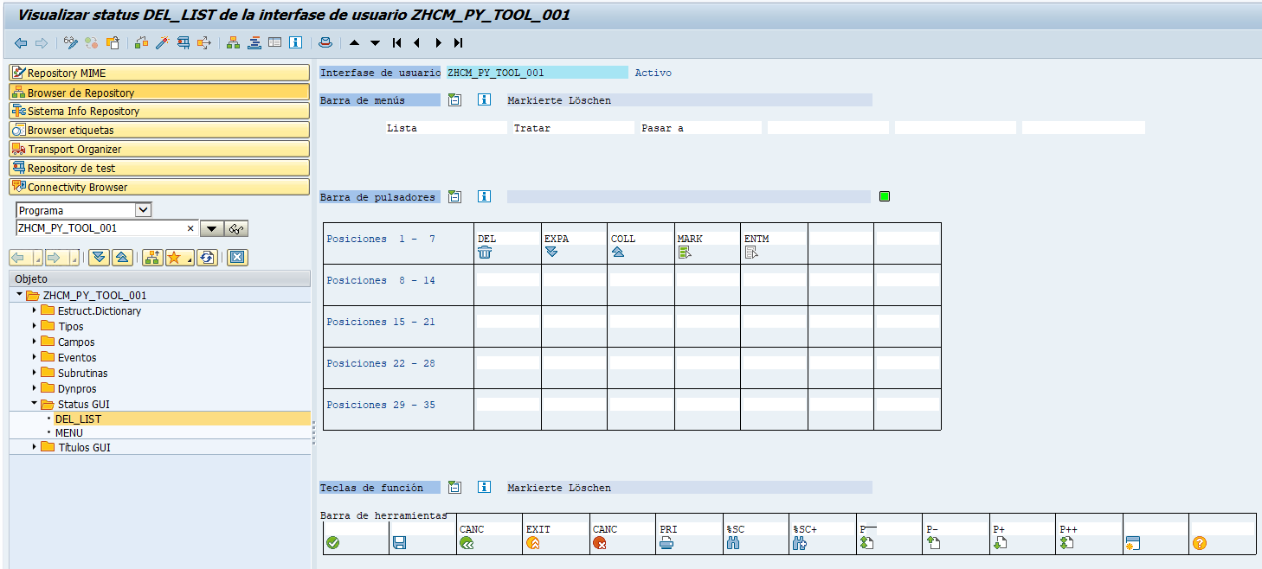

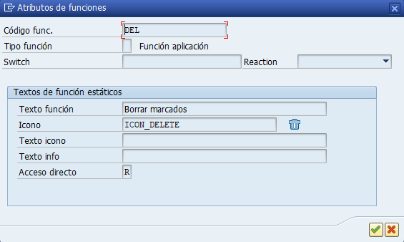

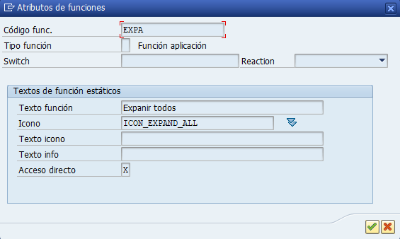

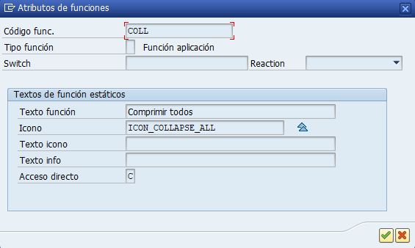

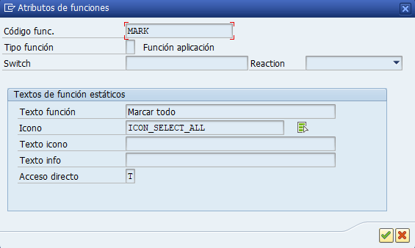

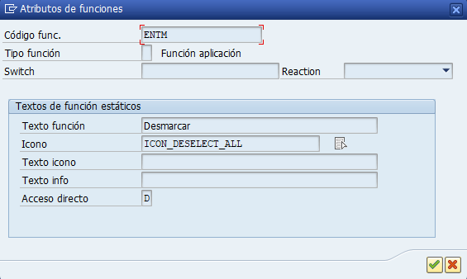

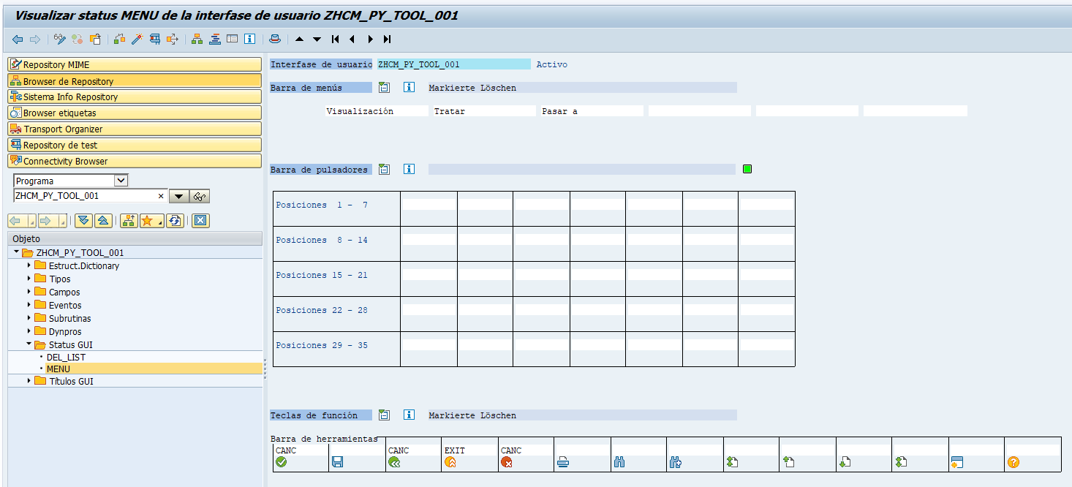

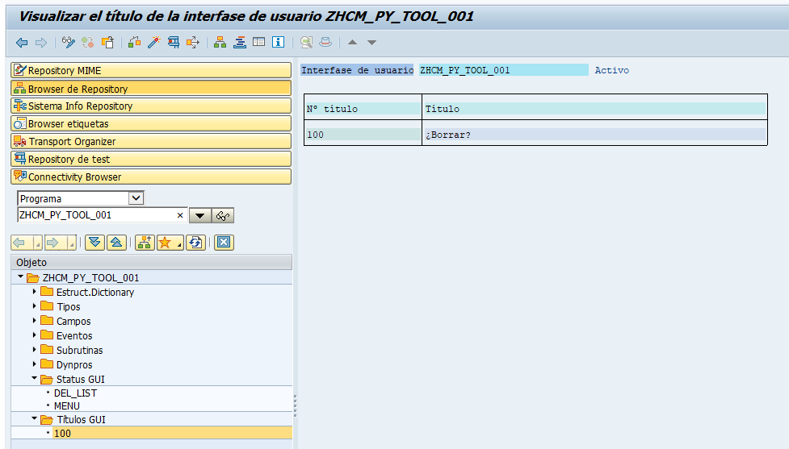

Ref

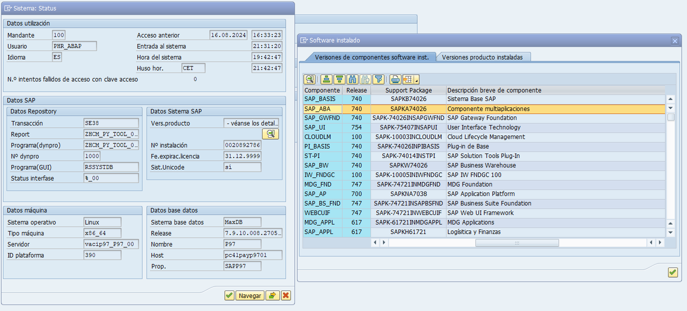

SAP_BASIS 740 0026 SAPKB74026 Sistema Base SAP

SAP_ABA 740 0026 SAPKA74026 Componente multiaplicaciones

SAP_GWFND 740 0026 SAPK-74026INSAPGWFND SAP Gateway Foundation

SAP_UI 754 0007 SAPK-75407INSAPUI User Interface Technology

CLOUDLM 100 0003 SAPK-10003INCLOUDLM Cloud Lifecycle Management

PI_BASIS 740 0026 SAPK-74026INPIBASIS Plug-in de Base

ST-PI 740 0014 SAPK-74014INSTPI SAP Solution Tools Plug-In

SAP_BW 740 0026 SAPKW74026 SAP Business Warehouse

IW_FNDGC 100 0005 SAPK-10005INIWFNDGC SAP IW FNDGC 100

MDG_FND 747 0021 SAPK-74721INMDGFND MDG Foundation

SAP_AP 700 0038 SAPKNA7038 SAP Application Platform

SAP_BS_FND 747 0021 SAPK-74721INSAPBSFND SAP Business Suite Foundation

WEBCUIF 747 0021 SAPK-74721INWEBCUIF SAP Web UI Framework

MDG_APPL 617 0021 SAPK-61721INMDGAPPL MDG Applications

SAP_APPL 617 0021 SAPKH61721 Logísitica y Finanzas

SAP_FIN 617 0021 SAPK-61721INSAPFIN SAP_FIN

SAP_HR 608 0097 SAPKE60897 Gestión de Recursos Humanos

SAP_HRCAE 608 0097 SAPK-60897INSAPHRCAE Sub component SAP_HRCAE of SAP_HR

SAP_HRCAR 608 0097 SAPK-60897INSAPHRCAR Sub component SAP_HRCAR of SAP_HR

SAP_HRCAT 608 0097 SAPK-60897INSAPHRCAT Sub component SAP_HRCAT of SAP_HR

SAP_HRCAU 608 0097 SAPK-60897INSAPHRCAU Sub component SAP_HRCAU of SAP_HR

SAP_HRCBE 608 0097 SAPK-60897INSAPHRCBE Sub component SAP_HRCBE of SAP_HR

SAP_HRCBG 608 0097 SAPK-60897INSAPHRCBG Sub component SAP_HRCBG of SAP_HR

SAP_HRCBR 608 0097 SAPK-60897INSAPHRCBR Sub component SAP_HRCBR of SAP_HR

SAP_HRCCA 608 0097 SAPK-60897INSAPHRCCA Sub component SAP_HRCCA of SAP_HR

SAP_HRCCH 608 0097 SAPK-60897INSAPHRCCH Sub component SAP_HRCCH of SAP_HR

SAP_HRCCL 608 0097 SAPK-60897INSAPHRCCL Sub component SAP_HRCCL of SAP_HR

SAP_HRCCN 608 0097 SAPK-60897INSAPHRCCN Sub component SAP_HRCCN of SAP_HR

SAP_HRCCO 608 0097 SAPK-60897INSAPHRCCO Sub component SAP_HRCCO of SAP_HR

SAP_HRCCZ 608 0097 SAPK-60897INSAPHRCCZ Sub component SAP_HRCCZ of SAP_HR

SAP_HRCDE 608 0097 SAPK-60897INSAPHRCDE Sub component SAP_HRCDE of SAP_HR

SAP_HRCDK 608 0097 SAPK-60897INSAPHRCDK Sub component SAP_HRCDK of SAP_HR

SAP_HRCEG 608 0097 SAPK-60897INSAPHRCEG Sub component SAP_HRCEG of SAP_HR

SAP_HRCES 608 0097 SAPK-60897INSAPHRCES Sub component SAP_HRCES of SAP_HR

SAP_HRCFI 608 0097 SAPK-60897INSAPHRCFI Sub component SAP_HRCFI of SAP_HR

SAP_HRCFR 608 0097 SAPK-60897INSAPHRCFR Sub component SAP_HRCFR of SAP_HR

SAP_HRCGB 608 0097 SAPK-60897INSAPHRCGB Sub component SAP_HRCGB of SAP_HR

SAP_HRCGR 608 0097 SAPK-60897INSAPHRCGR Sub component SAP_HRCGR of SAP_HR

SAP_HRCHK 608 0097 SAPK-60897INSAPHRCHK Sub component SAP_HRCHK of SAP_HR

SAP_HRCHR 608 0097 SAPK-60897INSAPHRCHR Sub component SAP_HRCHR of SAP_HR

SAP_HRCHU 608 0097 SAPK-60897INSAPHRCHU Sub component SAP_HRCHU of SAP_HR

SAP_HRCID 608 0097 SAPK-60897INSAPHRCID Sub component SAP_HRCID of SAP_HR

SAP_HRCIE 608 0097 SAPK-60897INSAPHRCIE Sub component SAP_HRCIE of SAP_HR

SAP_HRCIN 608 0097 SAPK-60897INSAPHRCIN Sub component SAP_HRCIN of SAP_HR

SAP_HRCIT 608 0097 SAPK-60897INSAPHRCIT Sub component SAP_HRCIT of SAP_HR

SAP_HRCJP 608 0097 SAPK-60897INSAPHRCJP Sub component SAP_HRCJP of SAP_HR

SAP_HRCKR 608 0097 SAPK-60897INSAPHRCKR Sub component SAP_HRCKR of SAP_HR

SAP_HRCKW 608 0097 SAPK-60897INSAPHRCKW Sub component SAP_HRCKW of SAP_HR

SAP_HRCKZ 608 0097 SAPK-60897INSAPHRCKZ Sub component SAP_HRCKZ of SAP_HR

SAP_HRCMX 608 0097 SAPK-60897INSAPHRCMX Sub component SAP_HRCMX of SAP_HR

SAP_HRCMY 608 0097 SAPK-60897INSAPHRCMY Sub component SAP_HRCMY of SAP_HR

SAP_HRCNL 608 0097 SAPK-60897INSAPHRCNL Sub component SAP_HRCNL of SAP_HR

SAP_HRCNO 608 0097 SAPK-60897INSAPHRCNO Sub component SAP_HRCNO of SAP_HR

SAP_HRCNZ 608 0097 SAPK-60897INSAPHRCNZ Sub component SAP_HRCNZ of SAP_HR

SAP_HRCOM 608 0097 SAPK-60897INSAPHRCOM Sub component SAP_HRCOM of SAP_HR

SAP_HRCPH 608 0097 SAPK-60897INSAPHRCPH Sub component SAP_HRCPH of SAP_HR

SAP_HRCPL 608 0097 SAPK-60897INSAPHRCPL Sub component SAP_HRCPL of SAP_HR

SAP_HRCPT 608 0097 SAPK-60897INSAPHRCPT Sub component SAP_HRCPT of SAP_HR

SAP_HRCQA 608 0097 SAPK-60897INSAPHRCQA Sub component SAP_HRCQA of SAP_HR

SAP_HRCRO 608 0097 SAPK-60897INSAPHRCRO Sub component SAP_HRCRO of SAP_HR

SAP_HRCRU 608 0097 SAPK-60897INSAPHRCRU Sub component SAP_HRCRU of SAP_HR

SAP_HRCSA 608 0097 SAPK-60897INSAPHRCSA Sub component SAP_HRCSA of SAP_HR

SAP_HRCSE 608 0097 SAPK-60897INSAPHRCSE Sub component SAP_HRCSE of SAP_HR

SAP_HRCSG 608 0097 SAPK-60897INSAPHRCSG Sub component SAP_HRCSG of SAP_HR

SAP_HRCSI 608 0097 SAPK-60897INSAPHRCSI Sub component SAP_HRCSI of SAP_HR

SAP_HRCSK 608 0097 SAPK-60897INSAPHRCSK Sub component SAP_HRCSK of SAP_HR

SAP_HRCTH 608 0097 SAPK-60897INSAPHRCTH Sub component SAP_HRCTH of SAP_HR

SAP_HRCTR 608 0097 SAPK-60897INSAPHRCTR Sub component SAP_HRCTR of SAP_HR

SAP_HRCTW 608 0097 SAPK-60897INSAPHRCTW Sub component SAP_HRCTW of SAP_HR

SAP_HRCUA 608 0097 SAPK-60897INSAPHRCUA Sub component SAP_HRCUA of SAP_HR

SAP_HRCUN 608 0097 SAPK-60897INSAPHRCUN Sub component SAP_HRCUN of SAP_HR

SAP_HRCUS 608 0097 SAPK-60897INSAPHRCUS Sub component SAP_HRCUS of SAP_HR

SAP_HRCVE 608 0097 SAPK-60897INSAPHRCVE Sub component SAP_HRCVE of SAP_HR

SAP_HRCZA 608 0097 SAPK-60897INSAPHRCZA Sub component SAP_HRCZA of SAP_HR

SAP_HRGXX 608 0097 SAPK-60897INSAPHRGXX Sub component SAP_HRGXX of SAP_HR

SAP_HRRXX 608 0097 SAPK-60897INSAPHRRXX Sub component SAP_HRRXX of SAP_HR

EA-IPPE 400 0032 SAPKGPID32 SAP iPPE

EA-APPL 617 0021 SAPK-61721INEAAPPL SAP R/3 Enterprise Extension PLM, SCM, Finanzas

EA-DFPS 600 0032 SAPKGPDD32 SAP Enterprise Extension Defense Forces & Public Security

EA-FIN 617 0021 SAPK-61721INEAFIN EA-FIN

EA-FINSERV 600 0033 SAPKGPFD33 SAP Enterprise Extension Financial Services

EA-GLTRADE 600 0032 SAPKGPGD32 SAP Enterprise Extension Global Trade

EA-HR 608 0097 SAPK-60897INEAHR SAP R/3 Enterprise Extension HR

EA-HRCAE 608 0097 SAPK-60897INEAHRCAE Sub component EA-HRCAE of EA-HR

EA-HRCAR 608 0097 SAPK-60897INEAHRCAR Sub component EA-HRCAR of EA-HR

EA-HRCAT 608 0097 SAPK-60897INEAHRCAT Sub component EA-HRCAT of EA-HR

EA-HRCAU 608 0097 SAPK-60897INEAHRCAU Sub component EA-HRCAU of EA-HR

EA-HRCBE 608 0097 SAPK-60897INEAHRCBE Sub component EA-HRCBE of EA-HR

EA-HRCBG 608 0097 SAPK-60897INEAHRCBG Sub component EA-HRCBG of EA-HR

EA-HRCBR 608 0097 SAPK-60897INEAHRCBR Sub component EA-HRCBR of EA-HR

EA-HRCCA 608 0097 SAPK-60897INEAHRCCA Sub component EA-HRCCA of EA-HR

EA-HRCCH 608 0097 SAPK-60897INEAHRCCH Sub component EA-HRCCH of EA-HR

EA-HRCCL 608 0097 SAPK-60897INEAHRCCL Sub component EA-HRCCL of EA-HR

EA-HRCCN 608 0097 SAPK-60897INEAHRCCN Sub component EA-HRCCN of EA-HR

EA-HRCCO 608 0097 SAPK-60897INEAHRCCO Sub component EA-HRCCO of EA-HR

EA-HRCCZ 608 0097 SAPK-60897INEAHRCCZ Sub component EA-HRCCZ of EA-HR

EA-HRCDE 608 0097 SAPK-60897INEAHRCDE Sub component EA-HRCDE of EA-HR

EA-HRCDK 608 0097 SAPK-60897INEAHRCDK Sub component EA-HRCDK of EA-HR

EA-HRCEG 608 0097 SAPK-60897INEAHRCEG Sub component EA-HRCEG of EA-HR

EA-HRCES 608 0097 SAPK-60897INEAHRCES Sub component EA-HRCES of EA-HR

EA-HRCFI 608 0097 SAPK-60897INEAHRCFI Sub component EA-HRCFI of EA-HR

EA-HRCFR 608 0097 SAPK-60897INEAHRCFR Sub component EA-HRCFR of EA-HR

EA-HRCGB 608 0097 SAPK-60897INEAHRCGB Sub component EA-HRCGB of EA-HR

EA-HRCGR 608 0097 SAPK-60897INEAHRCGR Sub component EA-HRCGR of EA-HR

EA-HRCHK 608 0097 SAPK-60897INEAHRCHK Sub component EA-HRCHK of EA-HR

EA-HRCHR 608 0097 SAPK-60897INEAHRCHR Sub component EA-HRCHR of EA-HR

EA-HRCHU 608 0097 SAPK-60897INEAHRCHU Sub component EA-HRCHU of EA-HR

EA-HRCID 608 0097 SAPK-60897INEAHRCID Sub component EA-HRCID of EA-HR

EA-HRCIE 608 0097 SAPK-60897INEAHRCIE Sub component EA-HRCIE of EA-HR

EA-HRCIN 608 0097 SAPK-60897INEAHRCIN Sub component EA-HRCIN of EA-HR

EA-HRCIT 608 0097 SAPK-60897INEAHRCIT Sub component EA-HRCIT of EA-HR

EA-HRCJP 608 0097 SAPK-60897INEAHRCJP Sub component EA-HRCJP of EA-HR

EA-HRCKR 608 0097 SAPK-60897INEAHRCKR Sub component EA-HRCKR of EA-HR

EA-HRCKW 608 0097 SAPK-60897INEAHRCKW Sub component EA-HRCKW of EA-HR

EA-HRCKZ 608 0097 SAPK-60897INEAHRCKZ Sub component EA-HRCKZ of EA-HR

EA-HRCMX 608 0097 SAPK-60897INEAHRCMX Sub component EA-HRCMX of EA-HR

EA-HRCMY 608 0097 SAPK-60897INEAHRCMY Sub component EA-HRCMY of EA-HR

EA-HRCNL 608 0097 SAPK-60897INEAHRCNL Sub component EA-HRCNL of EA-HR

EA-HRCNO 608 0097 SAPK-60897INEAHRCNO Sub component EA-HRCNO of EA-HR

EA-HRCNZ 608 0097 SAPK-60897INEAHRCNZ Sub component EA-HRCNZ of EA-HR

EA-HRCOM 608 0097 SAPK-60897INEAHRCOM Sub component EA-HRCOM of EA-HR

EA-HRCPH 608 0097 SAPK-60897INEAHRCPH Sub component EA-HRCPH of EA-HR

EA-HRCPL 608 0097 SAPK-60897INEAHRCPL Sub component EA-HRCPL of EA-HR

EA-HRCPT 608 0097 SAPK-60897INEAHRCPT Sub component EA-HRCPT of EA-HR

EA-HRCQA 608 0097 SAPK-60897INEAHRCQA Sub component EA-HRCQA of EA-HR

EA-HRCRO 608 0097 SAPK-60897INEAHRCRO Sub component EA-HRCRO of EA-HR

EA-HRCRU 608 0097 SAPK-60897INEAHRCRU Sub component EA-HRCRU of EA-HR

EA-HRCSA 608 0097 SAPK-60897INEAHRCSA Sub component EA-HRCSA of EA-HR

EA-HRCSE 608 0097 SAPK-60897INEAHRCSE Sub component EA-HRCSE of EA-HR

EA-HRCSG 608 0097 SAPK-60897INEAHRCSG Sub component EA-HRCSG of EA-HR

EA-HRCSI 608 0097 SAPK-60897INEAHRCSI Sub component EA-HRCSI of EA-HR

EA-HRCSK 608 0097 SAPK-60897INEAHRCSK Sub component EA-HRCSK of EA-HR

EA-HRCTH 608 0097 SAPK-60897INEAHRCTH Sub component EA-HRCTH of EA-HR

EA-HRCTR 608 0097 SAPK-60897INEAHRCTR Sub component EA-HRCTR of EA-HR

EA-HRCTW 608 0097 SAPK-60897INEAHRCTW Sub component EA-HRCTW of EA-HR

EA-HRCUA 608 0097 SAPK-60897INEAHRCUA Sub component EA-HRCUA of EA-HR

EA-HRCUN 608 0097 SAPK-60897INEAHRCUN Sub component EA-HRCUN of EA-HR

EA-HRCUS 608 0097 SAPK-60897INEAHRCUS Sub component EA-HRCUS of EA-HR

EA-HRCVE 608 0097 SAPK-60897INEAHRCVE Sub component EA-HRCVE of EA-HR

EA-HRCZA 608 0097 SAPK-60897INEAHRCZA Sub component EA-HRCZA of EA-HR

EA-HRGXX 608 0097 SAPK-60897INEAHRGXX Sub component EA-HRGXX of EA-HR

EA-HRRXX 608 0097 SAPK-60897INEAHRRXX Sub component EA-HRRXX of EA-HR

EA-PS 600 0032 SAPKGPPD32 SAP Enterprise Extension Public Services

EA-RETAIL 600 0032 SAPKGPRD32 SAP Enterprise Extension Retail

FINBASIS 600 0032 SAPK-60032INFINBASIS Financials Basis

CLOUD_PAY 100 0040 SAPK-10040INCLOUDPAY Cloud Payroll Cloud Operation Tools

ECC-DIMP 600 0032 SAPK-60032INECCDIMP DIMP

ERECRUIT 600 0032 SAPK-60032INERECRUIT E-Recruiting

FI-CA 600 0032 SAPK-60032INFICA FI-CA

FI-CAX 600 0032 SAPK-60032INFICAX FI-CA ampliado

INSURANCE 600 0032 SAPK-60032ININSURANC SAP Insurance

IS-CWM 600 0032 SAPK-60032INISCWM Solución sectorial Catch Weight Management

IS-H 600 0062 SAPK-60062INISH SAP Healthcare

IS-M 600 0032 SAPK-60032INISM SAP MEDIA

IS-OIL 600 0032 SAPK-60032INISOIL IS-OIL

IS-PS-CA 600 0032 SAPK-60032INISPSCA IS-PUBLIC SECTOR CUENTA CORRIENTE CONTRACTUAL

IS-UT 600 0032 SAPK-60032INISUT SAP Utilidades/Telecomunicación

LSOFE 617 0017 SAPK-61717INLSOFE LSOFE

ODTFINCC 600 0011 SAPK-60011INODTFINCC ODTFINCC 600

SEM-BW 600 0032 SAPKGS6032 SEM-BW: Strategic Enterprise Management

BP-CANW 740VD 0000 - Tech. Obj. for SAP BP pkg. act. based on BS 7i11 Cross Appl. objects and SAP NW

BP-ERP 617VH 0000 - SAP BP ADD-ON FOR ERP 617

BP-SOLBLD 70VA 0000 - Best Practices Solution Builder on EHP5

ST-A/PI 01U_731 0001 SAPKITAB9Z Servicetools for SAP Basis 731 and higher